Dear Professor Whited,

Thank you very much for the opportunity to submit a revised version of my manuscript, and for the clear guidance. I am thrilled to resubmit a revised manuscript. Detailed responses are included below, but first I would like to provide an overview of the main changes.

- The revised introduction states clearly the key contribution that sets this paper apart from my own prior work and the broader literature on changing bond-stock comovements. In short, macroeconomic dynamics have changed so much over the past 30 years that changing one set of parameters is insufficient to return bonds to their risky state of the 1980s. Instead, a “perfect storm” consisting of a change towards more volatile supply shocks and a more hawkish monetary policy rule is needed to generate such reversion in bond risks.

- The revised paper provides additional discussion and results supporting the calibration for the first subperiod. Following the AE’s suggestion, the paper includes the new Figure 8 showing that a high volatility of supply shocks is needed to replicate the bond-stock betas of the first subperiod starting from the second subperiod. The revised paper also includes new examples and references for supply shocks during the 1980s and 1990s, such as the sudden drop in oil prices in 1986. I also added a newspaper count exercise in the new Appendix Figure A1 showing that supply shocks were a substantial concern during the 1980s and 1990s.

- The revised paper provides an updated discussion of recent events. The new Section 5 emphasizes the difference between an initially weak Fed inflation response and a later much stronger Fed inflation response during the post-pandemic period, thereby reconciling my interpretation of events with the interpretation suggested by the referee. This interpretation of events through the lens of the model is consistent with the fact that inflation rose in 2021, but the policy rate remained at zero until 2022 and reached its new level only in the second half of 2023, as shown in the new Figure 9.

Thank you again for the opportunity to submit a revised version of this manuscript to the JFE. My apologies for taking slightly longer for this revision. I had a baby in September 2024, and I believe this timeline enabled me to respond fully and carefully to the thoughtful comments by the AE and referees.

Sincerely,

Carolin

Responses to Associate Editor

I would like to thank you for the opportunity to revise and resubmit this manuscript, and especially for your constructive and highly detailed feedback. These comments have enabled me to produce a revised version of the manuscript that I believe makes a much clearer contribution. My apologies for taking slightly longer for this revision. I had a baby in September 2024, and I believe this timeline enabled me to respond fully and carefully to your and the referees’ thoughtful comments.

It’s useful to start with the common threads from both reports. Both referees want to see:

- Better positioning of the manuscript in the literature, both in relation to the author’s earlier publications and other relevant contributions (a few scattered comments across the footnotes won’t suffice).

Reply: I substantially re-wrote the introduction. The revised introduction now contains an updated discussion of how the manuscript relates to the literature, both in terms of my own prior work and other authors’ contributions. See the third paragraph on p.1 and the broader literature discussion starting at the bottom of p.4 (“This paper contains distinct contributions over the broader literature (…)”). For a more detailed response, see my reply to your comment 1. below.

- A more extensive discussion/defense of the calibration of the monetary policy side of the economy across the two sub-periods, especially for the first portion of the sample, which the author uses as an example of a time dominated by supply-side shocks.

Reply: Following your suggestion, I added the new Figure 8 showing that a high volatility of supply shocks is needed to replicate the bond-stock betas of the first subperiod starting from the second subperiod. The revised paper also includes new examples and references for supply shocks during the 1980s and 1990s, such as the sudden drop in oil prices in 1986. I also added a newspaper count exercise in the new Appendix Figure A1 showing that supply shocks were a substantial concern during the 1980s and 1990s. For a more detailed response, see my reply to your comment 3. below.

If you decide to invite a resubmission, it should be made clear that the author must convincingly address these two points to have a chance at eventual publication in this Journal. The more negative referee raises several additional relevant points that the author should carefully address:

      - The manuscript builds heavily on some of the author’s earlier contributions. While I certainly agree on this point, I do not concur with the conclusion that this diminishes the relevance of the current work to the point of not being worthy of publication in a top finance journal. The paper analyzes an important empirical question: why didn’t the stock-risk exposures of nominal and real bonds change during the recent spike in inflation, despite perceived similarities with the 1970s and 1980s? The author answers this by estimating an equilibrium model across two subsamples, showing that the real and nominal sides of the economy have changed so much in the last 20 years that altering one set of parameters at a time (to match those of the earlier years) isn’t enough to revert the risk exposures. It takes a “perfect storm” (as the author puts it) to make nominal and real bonds as risky as they used to be. This is a potentially important point in the asset pricing literature, one, in my opinion, not automatically inferred from the author’s earlier papers. However, it’s paramount that the author provides a compelling argument about why the previous papers aren’t enough to fully examine this empirical fact in both the response and the next draft.

Reply: Thank you for these fantastic suggestions. I substantially re-wrote the introduction to clarify the contribution of this paper relative to my own prior work and the broader literature on bond-stock comovements. The main changes can be found in the following locations:

- I revised the first paragraph of the introduction to state the new empirical puzzle up-front, following your suggestion. Here, I say

“Figure 1 newly shows that nominal bond-stock betas remained negative for much of the inflationary post-pandemic period. This raises the question why -- different from the 1980s -- nominal bond-stock betas did not rise during the recent spike in inflation, despite perceived macroeconomic similarities.”

- The paper’s main conclusion that a “perfect storm” is needed is now stated up-front at the beginning of the introduction (see p.1, paragraph starting “Calibrating a New Keynesian equilibrium model (…)”).

- On p.1 of the introduction, I now state how the model in this paper is different from the literature, and in particular my own prior work (see p.1, paragraph starting “Despite the substantial literature studying historical bond-stock comovements (…)”).

- A more detailed discussion of how this manuscript contributes over the existing literature follows on pp.4-6 of the re-written introduction (starting on p.4 “This paper contains distinct contributions (…)).

In summary, while this paper builds on the previous literature, its model contains several changes giving it a unique ability to conduct counterfactual exercises with respect to the composition of macroeconomic shocks and the Taylor rule coefficients on bond-stock betas. One important predecessor paper, Campbell, Pflueger, and Viceira (2020, CPV), contains the same Euler equation, and prices bonds and stocks using the same habit-formation preferences with countercyclical risk premia. However, CPV is not as microfounded as the current manuscript, limiting its ability to conduct counterfactual exercises. While CPV contains reduced-form equations describing inflation and interest rate dynamics that bear some resemblance to a Phillips curve and Taylor rule, in CPV these are equilibrium dynamics and not structural equations. Concretely, the coefficients in CPV’s reduced-form inflation and interest rate dynamics often do not even have the signs that one would expect in structural equations and their shocks are correlated, so any change in these reduced-form dynamics in CPV must be interpreted as a combination of changes to monetary policy and the macroeconomic environment. By contrast, the current manuscript requires that the Phillips curve (20) and Taylor rule (24) have coefficients in line with the prior structural literature, and that their shocks are uncorrelated, as is standard for structural shocks. The model in CPV is therefore not sufficient to understand how counterfactual changes in macroeconomic volatilities and Taylor rule coefficients impact bond-stock betas.

The model in Pflueger and Rinaldi (2022, PR) is more similar to the current one, containing a structural Phillips curve and a Taylor-type monetary policy rule. However, PR do not study the implications for bond-stock betas and the PR model is insufficient to reach the central conclusion of this manuscript. The current model contains some important changes compared to PR, in particular both demand and supply shocks (PR has neither), and adaptive inflation expectations. The ability to perform counterfactual exercises to assess the impact of changes in the macroeconomic shock volatilities and Taylor rule coefficients on bond-stock betas therefore sets this paper apart from CPV and PR.

Regarding the broader literature on changing bond-stock comovements, there are several features that set the current manuscript apart. As discussed by referee 2, various channels have been proposed in the literature to explain the changes in bond-stock betas over the past four decades, including changing inflation risks (Piazzesi and Schneider (2006), David and Veronesi (2013), Song (2017), Bekaert and Engstrom (2017), Campbell, Pflueger, and Viceira (2020), Gourio and Ngo (2020), and Fang, Liu, and Roussanov (2022)); liquidity, flight-to-safety, and time-varying risk aversion (Baele, Bekaert, and Inghelbrecht (2010), Kozak (2022), and Laarits (2022)); permanent-transitory compositional changes of consumption growth (Chernov, Lochstoer, and Song (2021)); and changes in the monetary-fiscal mix regimes (Li, Zha, Zhang, and Zhou (2022)). The current paper incorporates these channels in a relatively parsimonious setup, where inflation risk and the permanent-transitory decomposition arise endogenously from the nature of macroeconomic shocks and monetary policy, and habit formation preferences give rise to time-varying risk aversion akin to endogenous “flight-to-safety”. While fiscal factors are not explicitly incorporated into the model, they can be thought of entering either as stimulating demand or driving inflation expectations similarly to supply-type shocks (Bianchi, Faccini, and Melosi (2023)).

One particularly closely related paper is Song (2017), which however uses a more reduced-form setup featuring an endowment economy, limiting its ability to speak to the role of macroeconomic shocks vs. monetary policy for bond-stock betas.

The model in this paper is also distinct from prior work that models the impact of changes to the volatilities of macroeconomic shocks or to monetary policy separately, whereas it is central to the conclusion in this paper to model these changes jointly. Different from the current paper, the production-based models of Fang, Liu, and Roussanov (2022), and Kozak (2022) do not incorporate changes in monetary policy. Conversely, Gourio and Ngo (2020) and Li et al. (2022) model changes in monetary and/or fiscal policy but do not incorporate changes in the composition of macroeconomic shocks. Those latter two models also acknowledge their limitations as models of asset prices, with basic moments such as the equity premium and equity return volatility either not reported or deviating substantially from the data. Finally, Gourio and Ngo (2022) consider a model where bond-stock comovements are closely linked to the level of inflation, assuming a constant volatility of technology shocks and no other shocks. Because of the close link between the level of inflation and bond-stock comovements in Gourio and Ngo (2022), their model is not suited to understanding the key empirical finding in this paper, namely that during 2021 bond-stock betas remained negative even as inflation rose to levels not seen in 40 years. Hence, different from the current manuscript, none of these previous papers are sufficient to reach the conclusion in this paper, namely that supply shocks and an inflation-centric monetary policy rule interact and are both necessary to make nominal bonds risky.

      - This referee doesn’t like some of the modeling assumptions. I’m not convinced by the “Taylor rule” comment (the author does include a shock in her MP rule that we could interpret as the discretionary component) and would like to see richer wage-price inflation dynamics. The author can address the latter (e.g., by introducing an additional shock to break the connection between the two inflation processes) and acknowledge some limitations in the modeling approaches.
Reply: The revised manuscript now clearly acknowledges the limitations of the Taylor rule as a model of monetary policy. While a monetary policy rule is a standard feature of many models of monetary policy, in practice monetary policy clearly also contains a discretionary component as captured by the monetary policy shock in equation (24) of the revised manuscript. This is now discussed at the top of p.13 in the paragraph starting “While there is an active debate to what extent monetary policy can be described by rules versus discretion (…)”.
To address the issue of richer wage-price inflation dynamics, the new Appendix Section G (online Appendix pp. 46-50) shows results for a model extension with richer price-wage dynamics. This new appendix section first solves the model with richer price-wage dynamics and then re-produces the paper’s main results analogous to Table 2 and Figure 4. The version of Figure 4 with a richer price-wage dynamics is reproduced below for your convenience (Appendix Figure A9).
The new Appendix Figure A9 shows that the asset pricing moments and key counterfactuals are robust and indeed quantitatively indistinguishable even when the volatility of the price-wage inflation shock is set to a plausible upper bound ($σ_{p}=0.55$). To keep the model exposition as simple as possible, I therefore abstract from richer price-wage inflation dynamics in the main paper. Following your suggestion, the revised manuscript newly acknowledges the limitations of the simple wage-price inflation dynamics and notes that the results are robust to relaxing the tight link between wage and price inflation dynamics. For this discussion, see the new footnote 9 on p. 12 in the paper.

Figure A9: Counterfactual Bond-Stock Betas with Richer Price-Wage Dynamics 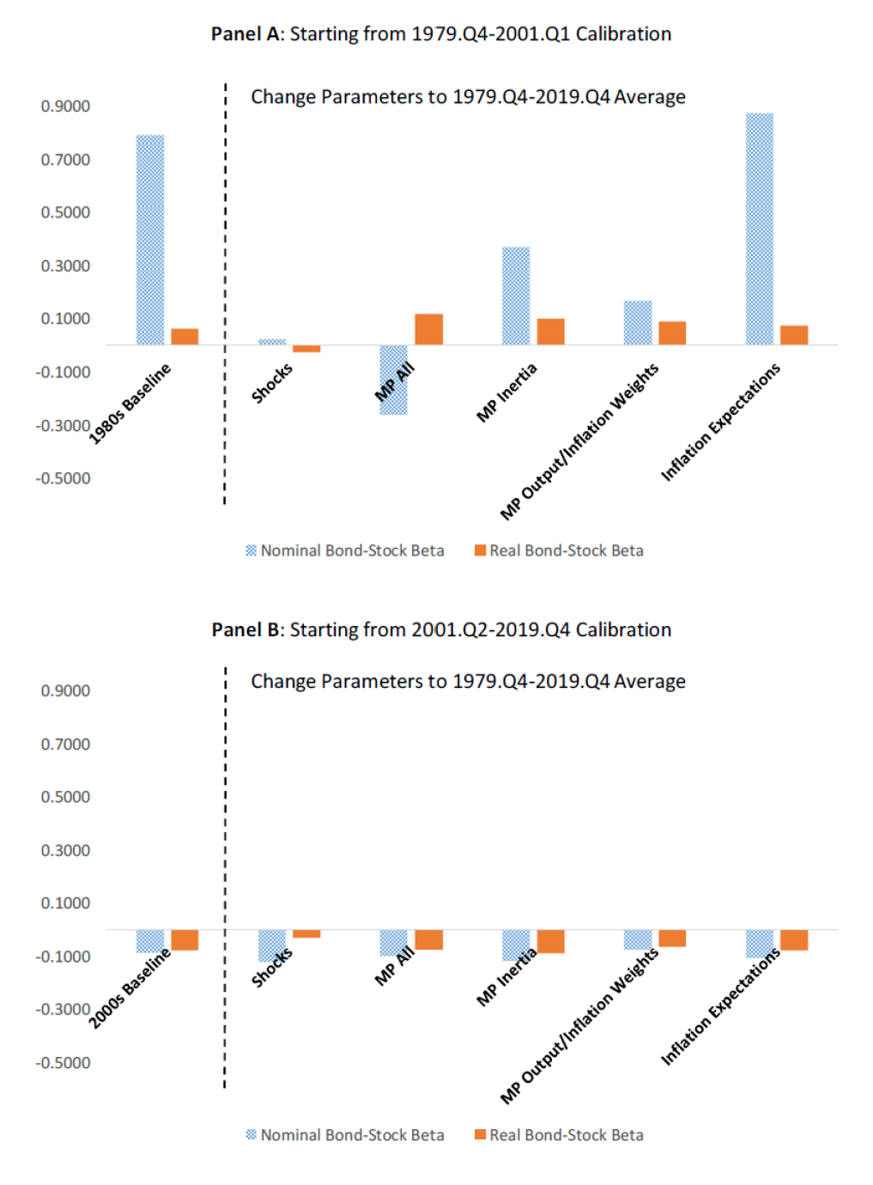

- This referee is concerned that viewing the 1980s as a prototypical example of supply-side shocks is incorrect. I’m sympathetic to this, as the 1970s are typically the more natural benchmark (although, in fairness, the JEP article by Goodfriend that this referee mentions in footnote 1 does say at the bottom of page 51 that “In January and February 1980 [. . . ], the spike in underlying inflation in connection with the ongoing oil price shock, the run-up in the dollar price of gold to $850 per ounce [. . . ]”, which one could argue as manifestations of supply shocks). Two potential avenues to address this issue are:
    - Extend the estimation of the first sample period to include the 1970s, though finding inflation expectations data may be challenging (I am not sure that Blue Chip forecasts go back that far in time). The author could use parametric forecasts of inflation in the spirit of Stock and Watson instead.
    - Calculate the necessary changes in parameters to replicate the stock betas from the first half of the sample in the second half. For example, is there a degree of MP inertia that would make the betas as big as they were in the first half of the sample? How much bigger should the volatilities of the shocks be to engineer the same betas?

Reply: I have addressed the issue twofold. First, I followed your suggestion to calculate the necessary changes in parameters to explain the nominal bond-stock betas during the 1980s from the second subperiod calibration (see the new Figure 8). This new figure clearly shows that volatile supply shocks are required to explain risky nominal Treasury bonds observed during the 1980s. Panel A of that figure is reproduced below for your convenience. The nominal bond-stock beta during the first subperiod is depicted with an orange plane, while blue circles depict model bond-stock betas. All parameters not explicitly mentioned are set to their values in the 2000s calibration listed in Table 1. The new Figure 8 shows that a high volatility of supply shocks is necessary to reverse-engineer the bond-stock betas observed during the first subperiod, further supporting a high supply shock volatility for the first calibration period. For a detailed discussion of this figure see the new Section 4.4 (pp.30-33) in the manuscript.

I refrained from calibrating the model to the 1970s period. While I agree that this was plausibly a period of substantial supply shock volatility, monetary policy during the 1970s was more complicated, which would complicate the analysis. In particular, it has been argued that during this period monetary policy opened up the economy to self-fulfilling sunspots or “inflation scares” (Clarida, Gali, and Gertler (1999), Goodfriend (2007)). While important, these issues are beyond the scope of this paper. The 1980s hence provide an ideal calibration period for this paper, as this period featured substantial supply shock uncertainty and a sufficiently inflation-responsive monetary policy rule, thereby sidestepping the issue of sunspots and self-fulfilling inflation expectations. I added a brief discussion to the introduction explaining why I calibrate the model to the 1980s rather than the 1970s (p3, paragraph starting “The calibrated changes…”).

Figure 8: Model Nominal Bond-Stock Beta vs. 1980s Bond-Stock Beta
Panel A: MP Inertia $ρ^{i}=0.54$

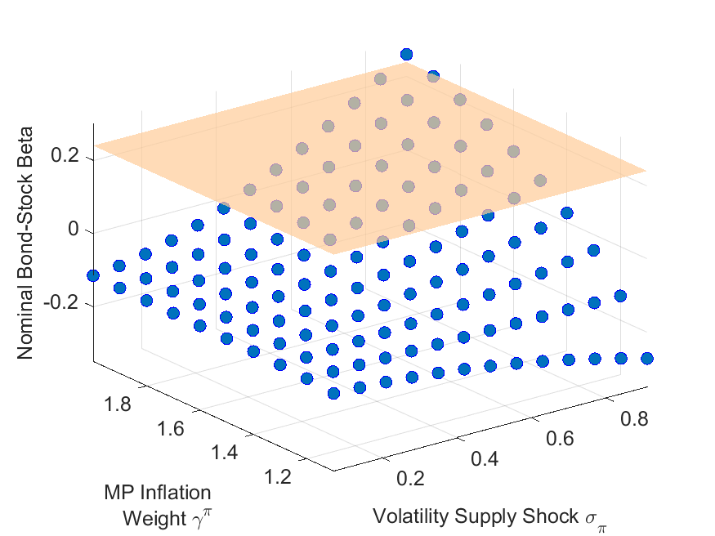

Second, the revised manuscript includes new anecdotes and references for examples of supply shocks during the 1980s and 1990s. It is important to keep in mind that in my model bond-stock betas depend on the volatility of supply shocks, but the sign of these shocks can be either positive or negative. While the 1970s were a period of dramatic adverse supply shocks, the 1980s and 1990s featured substantial supply shocks that tended to be positive, such as in 1986 when Saudi Arabia more than doubled its own oil output leading to a dramatic drop in oil prices (Gately, 1986). These shocks were viewed as highly relevant for monetary policy during 1980s and 1990s, as illustrated by the following quote from Greg Mankiw in a Fortune article from December 1997:

“SUPPLY SHOCKS: Sometimes outside events affect the prices at which firms supply their goods and services. The classic inflationary supply shocks were the OPEC oil price increases of the 1970s. As the cost of all oil-related products rose, the Fed had to cope with a less favorable tradeoff between inflation and unemployment. Greenspan has been more fortunate. Shortly before he was appointed Fed chairman in 1987, world oil prices plummeted, improving the inflation-unemployment tradeoff. Over the past two years, the foreign-exchange market has provided a similar benefit. The rise in the exchange rate from 90 to 120 yen per dollar has put downward pressure on the prices of imports and import-competing goods. And because wages respond to consumer prices, the strong dollar has also kept down growth in labor costs.”
(N. Gregory Mankiw, “Alan Greenspan’s Tradeoff”, Fortune, December 8, 1997)

Supply shocks arising from new technology and the “New Economy” were also highly salient to monetary policy makers during my first subperiod, and in particular during the 1990s. The puzzle for economists and policy makers during the 1990s was how the US economy was able to perform so well while inflation remained low. It is immediate that these empirical observations would contribute to the negative empirical inflation-output gap relationship displayed in the top-left panel of Figure 2, and hence to the identification of volatile supply shocks during my first calibration period. Fed Chair Alan Greenspan himself famously attributed the performance of the US economy with low inflation during this period to technology shocks and the “New Economy” in statements such as the following:

“As we have discussed before, powerful forces have evolved in the past few years to help contain inflationary tendencies. An ever-increasing share of our nation's workforce uses the tools of new technologies. Microchips embodied in physical capital make it work more efficiently, and sophisticated software adds to intellectual capital.”
(Chairman Alan Greenspan, Semiannual monetary policy report, U.S. Senate July 18, 1996)

Not all supply shocks during the 1980s and 1990s were positive, and as you mention Goodfriend (2007) refers to the 1980 and 1990/1991 (first gulf war) oil price increases as examples of adverse supply shocks. Also consistent with my break date, Goodfriend (2007) argues that the late 1990s represented a significant break in monetary policy towards a “new consensus”. I therefore view his insightful account of US monetary policy as supportive of the break date used in this manuscript.

To quantify this anecdotal evidence, I added a simple quantification for the perceived relevance of supply shocks across the decades using newspaper counts to the revised manuscript. The results are shown in the new Appendix Figure A1, reproduced below for your convenience. This figure shows for each decade the number of Wall Street Journal articles mentioning both “supply” and “inflation”, scaled by the number of articles mentioning “inflation” from Proquest Historical Newspapers. This new analysis shows that the share of supply mentions peaked in the 1980s. It even slightly increased from the 1970s to the 1980s. This seems plausible because the dramatic supply shocks during the 1970s arguably struck as a surprise, whereas by the 1980s and 1990s economists, the public, and investors had learned to worry about supply shocks and these worries were plausibly reflected in more frequent news mentions. The figure also shows a spike in the concern about supply-driven inflation during the post-pandemic period starting in 2020, similar to the level last observed during the 1980s. Overall, this analysis based on newspaper counts further supports the notion that the public and investors were highly attuned to macroeconomic supply shocks during the 1980s and again during the post-pandemic period after 2020.

Figure A1: Relative Frequency of Supply and Inflation in WSJ Articles
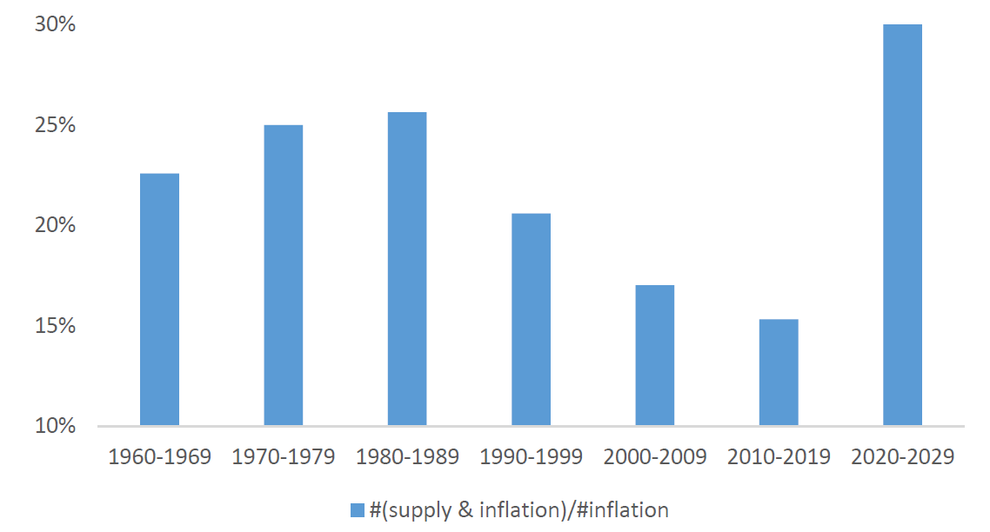
The revised manuscript discusses this news count evidence and prominent examples of supply shocks during my first subperiod in the following locations:
- p.3, paragraph starting “The calibrated changes in the monetary policy rule (…)
- new footnote 4 on p.3
- p.18, paragraph starting “A simple newspaper count exercise (…)”
- new footnote 14 on p.18

- The referee provides an alternative explanation for recent events, which the author should consider. It would also be useful to examine the likelihood of observing four 75bps rate increases in a year without changing some of the Taylor rule’s parameters. I suspect that one way to examine the story proposed by the referee at the top of page 3 would consist in changing some of the parameters of the model to levels that are similar to the first part of the sample. There is a sense in which this aligns with what the author does in her counterfactuals.
I think the reports contain relevant and well-crafted comments. Similarly, I think the paper has the potential to make an important contribution to the literature. In my opinion, it would be appropriate to offer the author an opportunity to address these comments.

Reply: Thank you for these excellent suggestions. The new Section 5 contains an updated discussion of recent events, dividing the analysis into an early post-pandemic (until 2023.Q2) and a late post-pandemic period (2023.Q3-Q4). I find that the model can explain nominal and real bond-stock betas during the early post-pandemic with a low inflation coefficient. However, the model requires a high inflation coefficient during the later post-pandemic. I hence find that in the late post-pandemic period, bond-stock betas indeed require changing the monetary policy rule to parameters that are more similar to the first part of the sample, just as you suggested.
Following your suggestion, the new Section 5 puts the model-implied monetary policy rule in the context of the recent inflation spike and the subsequent energetic policy rate hikes. The timeline of inflation and policy rates during the post-pandemic period are depicted in the new Figure 9. The key takeaway from this figure is that inflation rose already in 2021, well before the Fed started lifting interest rates. The policy rate initially remained constant, lifted off from zero in March 2022, and reached its new plateau in late 2023. This timeline suggests that supply shocks became salient in 2021, but a change in the monetary policy stance only occurred later.
To support this timeline of events, the revised paper also references my recent complementary paper Bauer, Pflueger, and Sunderam, (2024), which estimates the monetary policy inflation coefficient as perceived by professional forecasters from rich survey data, and links the change in the perceived monetary policy rule to policy rate surprises on FOMC dates. Table 2 of Bauer, Pflueger and Sunderam (2024) suggests that the perceived monetary policy inflation coefficient peaked during the second half of 2023. Even though the data and methodology in this complementary work are completely separate, it is interesting that the timing lines up closely with the significant increases in rolling nominal, real and breakeven betas in Figure 10 in the present manuscript.
The revised paper discusses the timeline of recent inflation and monetary policy on p.4 of the introduction and in more detail on p.33. The relative contribution of this paper over Bauer, Pflueger, and Sunderam, (2024a,b), is made clear in the literature review on p.6 of the introduction (“Complementary to this paper, Bauer, Pflueger, and Sunderam (2024a,b) (…)”) .

Figure 10 in Section 5 depicts rolling nominal, real, and breakeven betas from daily data during the post-pandemic period. Panel A shows that while nominal bond-stock betas show some higher frequency movements, they overall remained negative during the early post-pandemic and only turned decisively positive at the very end of sample in the second half of 2023. Panel B depicts rolling breakeven betas (or the difference between nominal and real bond-stock betas) with confidence intervals. This shows that until mid-2023 nominal bond-stock betas were either significantly lower than real bond-stock betas, or at least not statistically significantly different, indicating that the inflationary dynamics priced in bond-stock betas were still procyclical (since breakeven returns are inversely related to inflation expectations). However, in the second half of 2023, breakeven betas did turn significantly positive, suggesting that the priced cyclicality of inflation expectations had changed. I interpret these patterns as providing out-of-sample confirmation of the key model predictions, if supply shocks were a significant concern throughout the post-pandemic period, but the priced monetary policy rule changed from a low inflation coefficient in the early post-pandemic to a high inflation coefficient in the later post-pandemic. The manuscript contains a revised discussion of Figure 10 on pp.34-35.
The revised Table 3 provides a simple reverse-engineering exercise, showing that observed nominal and real bond-stock betas in the early and late post-pandemic periods can be matched with 1980s-style macroeconomic shocks, and a low monetary policy inflation coefficient during the early post-pandemic but a higher monetary policy inflation coefficient during the later post-pandemic. The results in Table 3 hence indicate that the monetary policy rule implied by bond-stock betas was similar to the 2000s during 2021 and 2022, but became more similar to the 1980s monetary policy rule during 2023 after the series of energetic rate hikes. The revised description of Table 3 can be found on pp. 36-37 of the paper.

Responses to Referee 1

Thank you for your careful reading of the manuscript and your insightful comments. I addressed them following the AE’s guidance, and am thrilled to resubmit a clearer and much improved manuscript. I include detailed point-by-point responses to your comments below.
- Lack of methodological novelty. This paper is too close to CPV. The model is mostly the same: in fact, most of the equations in Section 2 are the same as in CPV. The difference is the Phillips curve and the monetary policy rule described in Section 2.4 and 2.5. Methodologically, this is a relatively minor extension. Moreover, the structural additions are either not really structural or not very convincing. Specifically:
Reply: I substantially re-wrote the introduction to clarify this paper’s contribution following the detailed suggestions by the AE and referee 2. The unique contribution of this paper is now stated up-front in the second paragraph on p.1 as follows:
“Calibrating a New Keynesian equilibrium model for asset prices separately to the 1980s and the 2000s, I find that over the past 30 years monetary policy and the real side of the economy have changed sufficiently that reverting either set of parameters is insufficient to revert bond risks to their levels in the 1980s. Instead, a “perfect storm” consisting of a change towards more volatile supply shocks and a more hawkish monetary policy rule is needed to generate a reversion back to the risky bond markets of the 1980s.”

The next paragraph (p.1, starting “Despite the substantial literature (…)”) clarifies how the model in this paper differs from CPV and other key papers. Finally, the revised paper discusses how this paper contributes to the broader literature in a new literature review (pp. 4- 6, starting “This paper contains distinct contributions (…))

In summary, while this paper builds on the previous literature, its model contains several changes giving it a unique ability to conduct counterfactual exercises with respect to the composition of macroeconomic shocks and the Taylor rule coefficients on bond-stock betas. One important predecessor paper, Campbell, Pflueger, and Viceira (2020, CPV), contains the same Euler equation, and prices bonds and stocks using the same habit-formation preferences with countercyclical risk premia. However, CPV is not as microfounded as the current manuscript, limiting its ability to conduct counterfactual exercises. While CPV contains reduced-form equations describing inflation and interest rate dynamics that bear some resemblance to a Phillips curve and Taylor rule, in CPV these are equilibrium dynamics and not structural equations. Concretely, the coefficients in CPV’s reduced-form inflation and interest rate dynamics often do not even have the signs that one would expect in structural equations and their shocks are correlated, so any change in these reduced-form dynamics in CPV must be interpreted as a combination of changes to monetary policy and the macroeconomic environment. By contrast, the current manuscript requires that the Phillips curve (20) and Taylor rule (24) have coefficients in line with the prior structural literature, and that their shocks are uncorrelated, as is standard for structural shocks. The model in CPV is therefore not sufficient to understand how counterfactual changes in macroeconomic volatilities and Taylor rule coefficients impact bond-stock betas.

The model in Pflueger and Rinaldi (2022, PR) is more similar to the current one, containing a structural Phillips curve and a Taylor-type monetary policy rule. However, PR do not study the implications for bond-stock betas and the PR model is insufficient to reach the central conclusion of this manuscript. The current model contains some important changes compared to PR, in particular both demand and supply shocks (PR has neither), and adaptive inflation expectations. The ability to perform counterfactual exercises to assess the impact of changes in the macroeconomic shock volatilities and Taylor rule coefficients on bond-stock betas therefore sets this paper apart from CPV and PR.

Regarding the broader literature on changing bond-stock comovements, there are several features that set the current manuscript apart. As discussed by referee 2, various channels have been proposed in the literature to explain the changes in bond-stock betas over the past four decades, including changing inflation risks (Piazzesi and Schneider (2006), David and Veronesi (2013), Song (2017), Bekaert and Engstrom (2017), Campbell, Pflueger, and Viceira (2020), Gourio and Ngo (2020), and Fang, Liu, and Roussanov (2022)); liquidity, flight-to-safety, and time-varying risk aversion (Baele, Bekaert, and Inghelbrecht (2010), Kozak (2022), and Laarits (2022)); permanent-transitory compositional changes of consumption growth (Chernov, Lochstoer, and Song (2021)); and changes in the monetary-fiscal mix regimes (Li, Zha, Zhang, and Zhou (2022)). The current paper incorporates these channels in a relatively parsimonious setup, where inflation risk and the permanent-transitory decomposition arise endogenously from the nature of macroeconomic shocks and monetary policy, and habit formation preferences give rise to time-varying risk aversion akin to endogenous “flight-to-safety”. While fiscal factors are not explicitly incorporated into the model, they can be thought of entering either as stimulating demand or driving inflation expectations similarly to supply-type shocks (Bianchi, Faccini, and Melosi (2023)).

One particularly closely related paper is Song (2017), which however uses a more reduced-form setup featuring an endowment economy, limiting its ability to speak to the role of macroeconomic shocks vs. monetary policy for bond-stock betas.

The model in this paper is also distinct from prior work that models the impact of changes to the volatilities of macroeconomic shocks or to monetary policy separately, whereas it is central to the conclusion in this paper to model these changes jointly. Different from the current paper, the production-based models of Fang, Liu, and Roussanov (2022), and Kozak (2022) do not incorporate changes in monetary policy. Conversely, Gourio and Ngo (2020) and Li et al. (2022) model changes in monetary and/or fiscal policy but do not incorporate changes in the composition of macroeconomic shocks. Those latter two models also acknowledge their limitations as models of asset prices, with basic moments such as the equity premium and equity return volatility either not reported or deviating substantially from the data. Finally, Gourio and Ngo (2022) consider a model where bond-stock comovements are closely linked to the level of inflation, assuming a constant volatility of technology shocks and no other shocks. Because of the close link between the level of inflation and bond-stock comovements in Gourio and Ngo (2022), their model is not suited to understanding the key empirical finding in this paper, namely that during 2021 bond-stock betas remained negative even as inflation rose to levels not seen in 40 years. Hence, different from the current manuscript, none of these previous papers are sufficient to reach the conclusion in this paper, namely that supply shocks and an inflation-centric monetary policy rule interact and are both necessary to make nominal bonds risky.
- The Taylor rules are not structural relations. In practice, central banks set policy with discretion to achieve their mandates; they do not follow Taylor rules (although they might use them as benchmark). These rules are best interpreted as reduced form relations that approximate central bank behavior.
I followed the AE’s suggestion to address your concern about the monetary policy rule, and added a discussion of the limitations of the Taylor rule as a model of monetary policy. While a monetary policy rule is a standard feature of many models of monetary policy, in practice monetary policy clearly also contains a discretionary component as captured by the monetary policy shock in equation (24) of the revised manuscript. This new discussion can be found at the top of p.13 in the paragraph starting “While there is an active debate to what extent monetary policy can be described by rules versus discretion (…)”.
- The Phillips curve is generally the weakest part of New Keynesian models since there is much we don’t understand about inflation (we have a qualitative understanding). This paper’s Phillips curve is no exception. The paper assumes prices are flexible and wages are sticky, and derives a wage Phillips curve with backward and forward looking elements. This approach will miss a lot of richness that matters in practice, e.g., the Covid-19 shock showed that price and wage inflation can have very different dynamics.
I followed the AE’s guidance and considered a model extension featuring an additional shock to price vs. wage inflation, and showed that the model asset pricing moments and counterfactuals are robust. To address the issue of richer wage-price inflation dynamics, the new Appendix Section G (online Appendix pp. 46-50) shows results for a model extension with richer price-wage dynamics. This new appendix section first solves the model with richer price-wage dynamics and then re-produces the paper’s main results analogous to Table 2 and Figure 4. The version of Figure 4 with a richer price-wage dynamics is reproduced below for your convenience (Appendix Figure A9).
The new Appendix Figure A9 shows that the asset pricing moments and key counterfactuals are robust and indeed quantitatively indistinguishable even when the volatility of the price-wage inflation shock is set to a plausible upper bound ($σ_{p}=0.55$). To keep the model exposition as simple as possible, I therefore abstract from richer price-wage inflation dynamics in the main paper. Following your suggestion, the revised manuscript newly acknowledges the limitations of the simple wage-price inflation dynamics and notes that the results are robust to relaxing the tight link between wage and price inflation dynamics. For this discussion, see the new footnote 9 on p. 12 in the paper.

Figure A9: Counterfactual Bond-Stock Betas with Richer Price-Wage Dynamics 

The paper does not persuasively explain any new fact (beyond what we can tell based on CPV). Given the lack of methodological novelty, the paper should be evaluated in terms of how well it explains the motivating facts—specifically, the changing bond-stock betas. The paper claims that betas were positive in the earlier decades because “supply shocks” were more relevant and the Fed was more inflation focused and more alert (less inertial). This explanation is problematic for a number of reasons:
Reply: I revised the first paragraph of the introduction to state the new empirical puzzle up-front, following the AE’s suggestion. Here, I say
“Figure 1 newly shows that nominal bond-stock betas remained negative for much of the inflationary post-pandemic period. This raises the question why -- different from the 1980s -- nominal bond-stock betas did not rise during the recent spike in inflation, despite perceived macroeconomic similarities.”
I view post-pandemic betas as a particularly informative moment about the macroeconomic drivers of bond-stock betas because this recent period featured a spike in inflation not experienced in the US since the 1980s. CPV cannot speak to this empirical puzzle because its sample ends before the pandemic.
As discussed in detail in response to your previous comment, I also re-wrote the introduction to clarify how this paper’s conclusion and model are different from CPV and the broader literature on bond-stock betas.
  - A qualitative reading of history suggests that there were no major “supply shocks” in the 1980s (either empirically or “in investors’ minds”). Supply shocks were relevant in the 1970s—think oil/food price shocks and associated recessions. In the 1980s, the main issue was elevated inflation and its persistence (e.g., due to inflation expectations or experience affecting price-setting behavior). Chair Volcker hiked rates and generated a recession to reduce inflation. Afterward, there were several “inflation scares”—the markets were testing the Fed’s resolve to see whether they are serious about controlling inflation or whether inflation would flare up again. Over time, the Fed managed to keep inflation at its implicit target (2%). The Fed eventually gained credibility and inflation expectations became anchored. This credibility is why (among other things) bond-stock betas eventually turned negative.This
Given this history, what should we make of this paper’s explanation that this period featured dominant “supply shocks” with a fast and inflation-focused monetary policy? We can perhaps interpret the supply shocks as an “as-if” modeling device to capture inflation scares driven by weak credibility. But we could do a similar interpretation for CPV. This paper’s ambition appears to go deeper than CPV and provide a “structural” interpretation rather than an as-if interpretation. But the structural interpretation does not seem correct.

Reply: I have addressed the issue twofold. First, I followed the AE’s suggestion to calculate the necessary changes in parameters to explain the nominal bond-stock betas during the 1980s from the second subperiod calibration (see the new Figure 8). This new figure clearly shows that volatile supply shocks are required to explain risky nominal Treasury bonds observed during the 1980s. Panel A of that figure is reproduced below for your convenience. The nominal bond-stock beta during the first subperiod is depicted with an orange plane, while blue circles depict model bond-stock betas. All parameters not explicitly mentioned are set to their values in the 2000s calibration listed in Table 1. The new Figure 8 shows that a high volatility of supply shocks is necessary to reverse-engineer the bond-stock betas observed during the first subperiod, further supporting a high supply shock volatility for the first calibration period. For a detailed discussion of this figure see the new Section 4.4 (pp.30-33) in the manuscript.

I refrained from calibrating the model to the 1970s period. While I agree that this was plausibly a period of substantial supply shock volatility, monetary policy during the 1970s was more complicated, which would complicate the analysis. In particular, it has been argued that during this period monetary policy opened up the economy to self-fulfilling sunspots or “inflation scares” (Clarida, Gali, and Gertler (1999), Goodfriend (2007)). While important, these issues are beyond the scope of this paper. The 1980s hence provide an ideal calibration period for this paper, as this period featured substantial supply shock uncertainty and a sufficiently inflation-responsive monetary policy rule, thereby sidestepping the issue of sunspots and self-fulfilling inflation expectations. I added a brief discussion to the introduction explaining why I calibrate the model to the 1980s rather than the 1970s (p3, paragraph starting “The calibrated changes…”).

Figure 8: Model Nominal Bond-Stock Beta vs. 1980s Bond-Stock Beta
Panel A: MP Inertia $ρ^{i}=0.54$



Second, the revised manuscript includes new anecdotes and references for examples of supply shocks during the 1980s and 1990s. It is important to keep in mind that in my model bond-stock betas depend on the volatility of supply shocks, but the sign of these shocks can be either positive or negative. While the 1970s were a period of dramatic adverse supply shocks, the 1980s and 1990s featured substantial supply shocks that tended to be positive, such as in 1986 when Saudi Arabia more than doubled its own oil output leading to a dramatic drop in oil prices (Gately, 1986). These shocks were viewed as highly relevant for monetary policy during 1980s and 1990s, as illustrated by the following quote from Greg Mankiw in a Fortune article from December 1997:

“SUPPLY SHOCKS: Sometimes outside events affect the prices at which firms supply their goods and services. The classic inflationary supply shocks were the OPEC oil price increases of the 1970s. As the cost of all oil-related products rose, the Fed had to cope with a less favorable tradeoff between inflation and unemployment. Greenspan has been more fortunate. Shortly before he was appointed Fed chairman in 1987, world oil prices plummeted, improving the inflation-unemployment tradeoff. Over the past two years, the foreign-exchange market has provided a similar benefit. The rise in the exchange rate from 90 to 120 yen per dollar has put downward pressure on the prices of imports and import-competing goods. And because wages respond to consumer prices, the strong dollar has also kept down growth in labor costs.”
(N. Gregory Mankiw, “Alan Greenspan’s Tradeoff”, Fortune, December 8, 1997)

Supply shocks arising from new technology and the “New Economy” were also highly salient to monetary policy makers during my first subperiod, and in particular during the 1990s. The puzzle for economists and policy makers during the 1990s was how the US economy was able to perform so well while inflation remained low. It is immediate that these empirical observations would contribute to the negative empirical inflation-output gap relationship displayed in the top-left panel of Figure 2, and hence to the identification of volatile supply shocks during my first calibration period. Fed Chair Alan Greenspan himself famously attributed the performance of the US economy with low inflation during this period to technology shocks and the “New Economy” in statements such as the following:

“As we have discussed before, powerful forces have evolved in the past few years to help contain inflationary tendencies. An ever-increasing share of our nation's workforce uses the tools of new technologies. Microchips embodied in physical capital make it work more efficiently, and sophisticated software adds to intellectual capital.”
(Chairman Alan Greenspan, Semiannual monetary policy report, U.S. Senate July 18, 1996)

Not all supply shocks during the 1980s and 1990s were positive. As mentioned by the AE, Goodfriend (2007) refers to the 1980 and 1990/1991 (first gulf war) oil price increases as examples of adverse supply shocks. Consistent with my break date, Goodfriend (2007) argues that the late 1990s represented a significant break in monetary policy towards a “new consensus”. I therefore view Goodfriend (2007)’s insightful account of US monetary policy as supportive of the break date used in this manuscript.

To quantify this anecdotal evidence, I added a simple quantification for the perceived relevance of supply shocks across the decades using newspaper counts to the revised manuscript. The results are shown in the new Appendix Figure A1, reproduced below for your convenience. This figure shows for each decade the number of Wall Street Journal articles mentioning both “supply” and “inflation”, scaled by the number of articles mentioning “inflation” from Proquest Historical Newspapers. This new analysis shows that the share of supply mentions peaked in the 1980s. It even slightly increased from the 1970s to the 1980s. This seems plausible because the dramatic supply shocks during the 1970s arguably struck as a surprise, whereas by the 1980s and 1990s economists, the public, and investors had learned to worry about supply shocks and these worries were plausibly reflected in more frequent news mentions. The figure also shows a spike in the concern about supply-driven inflation during the post-pandemic period starting in 2020, similar to the level last observed during the 1980s. Overall, this analysis based on newspaper counts further supports the notion that the public and investors were highly attuned to macroeconomic supply shocks during the 1980s and again during the post-pandemic period after 2020.

Figure A1: Relative Frequency of Supply and Inflation in WSJ Articles


The revised manuscript discusses this news count evidence and prominent examples of supply shocks during my first subperiod in the following locations of the revised manuscript:
- p.3, paragraph starting “The calibrated changes in the monetary policy rule (…)
- new footnote 4 on p.3
- p.18, paragraph starting “A simple newspaper count exercise (…)”
- new footnote 14 on p.18

  - A similar qualitative look at the recent decades suggests the Fed is not less focused on inflation and it is not more inertial, compared to the 1980s. As I already mentioned, the Fed managed to keep inflation around 2% for decades until the Covid-19 shock. Inflation flared up recently, but that is because Covid-19 was a large and unusual supply shock. The Fed made a mistake in thinking that this shock was more transitory than it was (the markets made the same mistake throughout 2021). There is no evidence that the Fed was less inflation focused or less inertial. In fact, once the Fed realized its mistake, it quickly reversed course and started a very aggressive hiking campaign: raising interest rates by 500 basis points in one year. This seems like the opposite of an inertial central bank.
In terms of the behavior of inflation expectations and stock-bond betas in the Covid-19 cycle, there is a simpler explanation than what this paper proposes. The Fed has gained credibility so inflation expectations have not changed very much (beyond a few years). At the same time, because of large macroeconomic shocks (both supply and demand), the Fed had to move interest rates much more than in the past to shift financial conditions and control inflation. The prevalence of macroeconomic shocks increased the interest rate volatility and the bond-stock betas starting from a negative level. This story does not require a change in the Fed’s inertia or inflation focus, and it does not require a complicated model with habit formation.
Reply: The new Section 5 clarifies the account of recent events implied by the model. I believe that this re-written model-implied account of recent events lines up closely with your narrative above and thereby addresses your comment: According to the model, this was a period of large supply shocks, the Fed initially responded little to the increase in inflation, but subsequently switched to a strong and active inflation response. The quantitative implications in the revised Table 3 are very similar to before, so in that sense this account of recent events is not new compared to the previous version of the manuscript. But I realized that it did not come across sufficiently clearly, I completely re-wrote the account of recent events both in the introduction and in the new Section 5.
Section 5 divides the analysis of recent events into an early post-pandemic (until 2023.Q2) and a late post-pandemic period (2023.Q3-Q4). In short, this Section finds that to explain nominal and real bond-stock betas during the post-pandemic, the model requires a low monetary policy inflation coefficient in the early post-pandemic, but switches to a high monetary policy inflation coefficient in the late post-pandemic. The model also requires macroeconomic shock volatilities similar to the 1980s for the entire post-pandemic period.
To set the stage, the new Figure 9 shows that the initial run-up in inflation during the early post-pandemic was accompanied by little change in monetary policy. As you point out, the Fed eventually did show an energetic response to inflation, lifting interest rates by more than 500 bps by August 2023. However, this response occurred with a substantial lag relative to the initial run-up of inflation, which already occurred in 2021. Figure 10 shows rolling nominal and real bond-stock betas and breakeven betas, showing that nominal bond betas remained negative during the early post-pandemic but did turn positive in the second half of 2023, roughly coinciding with the Fed’s more energetic inflation response. Table 3 shows the model-implied monetary policy and shock parameters required to fit nominal and real bond-stock betas during the recent period, dividing the post-pandemic period into an early post-pandemic (2020.Q2-2023.Q2) and a late post-pandemic (2023.Q3-2023.Q4). I find that the model can fit bond-stock betas during both post-pandemic episodes. To do so, it requires 1980s-style shocks with a high volatility of supply shocks, a low monetary policy inflation coefficient during the early post-pandemic, but a much higher inflation coefficient during the later post-pandemic.

This model-implied account of recent events lines up with the basic timeline in Figure 9. The substantial but late change in the model-implied monetary policy rule is also consistent with empirical evidence from rich survey data (Bauer, Pueger, and Sunderam (2024b)). This complementary work provides evidence using a completely different approach and data from this paper. To be clear Bauer, Pflueger, and Sunderam (2024b) do not contain a general equilibrium asset pricing model nor do they study bond-stock betas, so the current manuscript has the unique ability to explain bond-stock betas. The distinction of the present manuscript over Bauer, Pflueger, and Sunderam, (2024a,b) is discussed in the introduction (p.6, “Complementary to this paper, Bauer, Pflueger, and Sunderam (2024a,b) (…)”).

More broadly, the formal general equilibrium framework in this paper provides a tool to unify various channels priced in bond-stock betas. The model accounts for a variety of channels in a relatively parsimonious manner, including “sentiment” or risk premium shocks, the rationality of inflation expectations, and the monetary policy response to macroeconomic shocks. By incorporating these various channels, the new Section 5 ties together the channels mentioned in your comment in an equilibrium framework. I newly describe this contribution of my paper in the introduction (p.5, “The model in this paper incorporates these channels in a relatively parsimonious setup (…)”). The revised Section 4 makes clear how “sentiment” shocks are accounted for in the model (p. 29, “One might wonder whether “sentiment” shocks could turn bond-stock betas negative (…)”). To address your comment about the anchoring of inflation expectations during the recent period, the revised manuscript makes clear that inflation expectations for the recent period are assumed to be rational at the top of p.37 (“To account for strongly anchored long-term inflation expectations during the recent period (…)”).

Responses to Referee 2

Thank you for your suggestions, and especially your lucid discussion of the literature. Following your and the AE’s suggestions, I re-wrote the introduction to delineate more clearly how the current manuscript stands out from the existing literature. The revised paper also contains additional discussion and results supporting the calibration for the first subperiod. Detailed point-by-point responses to your comments are included below.

In this sense, the paper’s setup builds on the author’s previous two published papers, Campbell, Pflueger, and Viceira (2020) and Pflueger and Rinaldi (2022), as they both include (P1) and (P2). While the model (P1) in Campbell, Pflueger, and Viceira (2020) is not as micro-founded as the one in the current paper, (P1) in Pflueger and Rinaldi (2022) is very similar, but with some important changes such as enriching structural shocks to include both demand and supply, and considering adaptive subjective inflation expectations.

The calibration of the model for two distinct subperiods sets the current paper apart from Pflueger and Rinaldi (2022), while its unique ability to perform counterfactual exercises assessing the impact of Taylor-rule coefficients and macroeconomic shock volatilities on bond-stock betas amplifies its significance.

In the literature, various channels explain bond-stock comovement, including the inflation-risk narrative proposed by David and Veronesi (2013), Song (2017), Campbell, Pflueger, and Viceira (2020), Gourio and Ngo (2020), and Fang, Liu, and Roussanov (2022); the liquidity, flight-to-safety, and time-varying risk aversion argument presented by Baele, Bekaert, and Inghelbrecht (2010), Kozak (2022), and Laarits (2022); examination of permanent-transitory compositional changes discussed by Chernov, Lochstoer, and Song (2021); and the examination of monetary-fiscal mix regimes explored by Li, Zha, Zhang, and Zhou (2022), among others.

What sets the current paper apart is its remarkable ability to integrate these popular narratives within a relatively simple unified framework. It adeptly incorporates elements such as the inflation risk narrative through the differentiation of demand versus supply shocks, time-varying risk aversion via habit-formation preferences, adjustments in the persistence of state variables, achieved by calibrating the model for two distinct subperiods, and modifications in the monetary policy rule, all contributing to a comprehensive understanding of bond-stock comovement.
Overall, I believe the paper merits publication in the Journal of Financial Economics. While I find the current paper already quite clear, I will only raise two relatively minor points.
Firstly, considering that the paper’s primary contribution focuses on explaining changing bond-stock comovement, I recommend that the author provide a more precise explanation of her contribution to the literature. Although the author cites most of the papers mentioned above in the paper, many of them are relegated to footnotes. For example, among the more pertinent papers, the author’s paper undoubtedly presents advancements beyond Song (2017), which also discussed changes in the monetary policy rule within an endowment economy, and it extends Campbell, Pflueger, and Viceira (2020), where the monetary policy rule isn’t specified. None of the production-based papers mentioned above, such as Gourio and Ngo (2020), Fang, Liu, and Roussanov (2022), and Kozak (2022), incorporate changes in the monetary policy rule. However, the work of Li, Zha, Zhang, and Zhou (2022) is somewhat unclear, as it also explores changes in policy rules, encompassing both monetary and fiscal aspects. The distinction may lie in the fact that Li, Zha, Zhang, and Zhou (2022) do not consider changes in volatility related to structural shocks. Clarifying both the precise contribution of this paper and that of others would be beneficial for readers to comprehend its position in the literature.

Reply: I liked your summary a lot and found it very helpful to clarify the current manuscript’s relationship to the literature. The revised manuscript now highlights the papers’ key difference relative to the key papers you mentioned at the very beginning of the introduction (see p.1, paragraph starting "Despite the substantial literature studying bond-stock comovements (…)”).

A new detailed discussion of how this paper contributes over the broader literature on bond-stock betas is included at the end of the introduction (starting at the bottom of p.4 “This paper contains distinct contributions over the broader literature studying changing bond-stock comovements. (…)”) All papers mentioned in your report are now described in the text of the introduction, and previous footnotes containing these references have been moved to the main text.

Secondly, while I generally agree with the author’s calibration across two periods, denoted as R1 and R2 in my report, I recommend that the author provide more discussion regarding the existing macro literature on calibration. The author has touched upon this to some extent in footnote 4, where she discussed the shift to a more inertial monetary policy rule with greater emphasis on output, aligning with anecdotal evidence. However, the part concerning dominant supply shocks in the 80s versus demand shocks in the 00s may warrant further discussion. In particular, Table 1 highlights a substantial difference in the magnitudes of volatilities $σ_{j}$ for $j ∈\{x,π, i\}$ across the two periods. Two notable references, Liu, Waggoner, and Zha (2011) and Bianchi and Ilut (2017), offer diverse volatility estimates within regime-switching New Keynesian models, both of which are highly cited. However, given the intricacies of their respective frameworks, which incorporate a broader array of structural shocks, direct comparisons may be challenging. In light of this complexity, it becomes imperative for the reader to discern whether the current paper’s calibration, particularly on (P1), aligns broadly with the trends observed in the macro DSGE literature. Should disparities arise, elucidating the rationale behind such deviations becomes essential. This clarity is paramount, especially considering that subsequent counterfactual analyses pivot critically on the calibration values delineated in Table 1.

Reply: Thank you for this helpful comment. I added a detailed discussion of the shock volatility calibrations and their relationship to the DSGE literature with regime switches to the revised manuscript.

Liu, Waggoner and Zha (2011) and Bianchi and Ilut (2017) both rely on samples that start significantly earlier and end earlier than the one in this paper, and allow only for two different volatility regimes. As a result, they naturally detect one switch in shock volatilities around or shortly after 1980, characterized by a roughly proportional decline in the volatilities of all shocks. My sample starts roughly at the time of their switch in volatilities. I therefore cannot detect the shift from high volatility to low volatility that they focus on. I use a break around 2000 and estimate a shift in the relative volatilities of supply-type v. demand-type shocks. This break date is supported by the more reduced-form approach to regime switches of Sims and Zha (2006) and the monetary policy model with term premia of Bianchi, Lettau, and Ludvigson (2022), who also detect switches around 2000.

In addition, a common shift in all volatilities would leave regression coefficients, such as the target moments depicted in Figure 2, unchanged, so my calibration procedure naturally is more sensitive to relative shifts in the volatilities of shocks. The overall volatility of shocks is identified in my calibration from the macroeconomic volatilities in the bottom panel of Table 3, but it is less central to the question studied here than in the macroeconomics literature on regime switches. The revised manuscript clarifies the relationship to Liu, Waggoner, and Zha (2011) and Bianchi and Ilut (2017) in the introduction (p.6 “This paper is also complementary to a long-standing literature on DSGE models with regime switches (…)”) and in the calibration section (p.21, paragraph starting “The change in the shock volatilities in Table 1 is consistent (…)”).

To further support the high supply shock volatility in my 1980s calibration, I added a discussion of examples of supply shocks during this period, and a simple newspaper count exercise to the revised manuscript. The newspaper count exercise is shown in the new Appendix Figure A1, reproduced below for your convenience. See the introduction (p.3 “The calibrated changes in the monetary policy rule and the nature of macroeconomic shocks are consistent with anecdotal evidence…”) and the calibration section (last paragraph on p.18, and new footnote 14).

Figure A1: Relative Frequency of Supply and Inflation in WSJ Articles

Following the suggestion of the AE, I also added a new reverse-engineering exercise showing that a high volatility of supply shocks is needed to explain the bond-stock betas of the 1980s starting from the 2000s calibration. These results are shown in the new Figure 8 in the paper and discussed in the new Section 4.4 starting on p.30.

This paper has a nice review of this period https://www.aeaweb.org/articles?id=10.1257/jep.21.4.47
The baseline negative bond-stock correlations are likely driven by risk premium or sentiment shocks (or any financial shock that affects stock prices more than bond prices). These shocks are common and they affect stock prices without changing potential output by much. The Fed naturally responds to these shocks in a stabilizing direction, e.g., they cut rates after a stock price decline (the Fed put). This response (and its anticipation) creates a negative correlation between stocks and bonds.

